# **Planning and Progress Report**

**Group**: C1.027  
**Repository**: <https://github.com/DP2-C1-027/AirNav-Logistics.git>

### **Group Members:**

1. **Garcia de Tejada Delgado, Jose**
   * Role: Developer
   * Email: josgardel8@alum.us.es
2. **Peñaloza Friqui, Nora**
   * Role: Developer
   * Email: norpennfri@alum.us.es
3. **Niza Cobo, Manuel Jesús**
   * Role: Manager, Developer
   * Email: mannizcob@alum.us.es
4. **Gomez Claraco, Nicolas**
   * Role: Developer
   * Email: nicgomcla@alum.us.es
5. **Campos Diez, Lucia**
   * Role: Tester, Developer
   * Email: luccamdie@alum.us.es

03/12/2025

## **Table of Contents**

1. **Executive Summary**
2. **Revision Table**
3. **Introduction**
4. **Planning Chapter**
   * Tasks Performed
   * Estimated Budget
5. **Progress Chapter**
   * Progress Records
   * Conflicts and Resolution
   * Cost Comparison
6. **Conclusions**
7. **Bibliography**

## 

## 

## 

## 

## 

## 

## 

## 

## 

## 

## 

## 

## **Executive Summary**

This report aims to present the analysis, planning, and progress of the *AirNav-Logistics* project, which is being developed to create a comprehensive logistics management system for charter flights at airports. The document details the completed tasks, the progress of features, and the estimated and actual budget. It also covers the working methodology, conflicts encountered during development, and a comparison of the estimated and real costs. The purpose is to ensure the project is progressing according to plan, within the allocated time and budget.

## **Revision Table**

|  |  |  |
| --- | --- | --- |
| **Revision** | **Date** | **Description** |
| 1 | 02/19/2025 | Creation of the analysis, planning, and progress report. D01 |
| 2 | 03/12/2025 | Update the analysis, planning and progress report for D02 |
| 3 | 03/31/2025 | Update the analysis, planning and progress report for D03 |

## **Introduction**

This report presents the analysis, planning, and progress made in the AirNav-Logistics project developed by group C1.027. The objective of this project is to create a system that helps airports manage resources for charter flights. The report is divided into two chapters: planning and progress, which include a detailed description of the assigned tasks, their execution, associated costs, and managed conflicts.

The structure of the report includes a breakdown of the tasks performed by Nora Peñaloza Friqui, an analysis of the costs involved, and a summary of the conflicts resolved during the project's development.

## 

## 

## 

## **Planning Chapter**

### **Tasks Performed:**

**→Individual requirements:**

**Task 1: Modify the anonymous menu**

* **Description:** The anonymous menu was modified to display an option that redirects the browser to the homepage of a favorite website, with the title formatted as: “〈id-number〉: 〈surname〉, 〈name〉”.
* **Assigned to:** Nora Peñaloza (developer)
* **Planned Time:** 30 minutes
* **Actual Time:** 15 minutes

**Task 2: Provide a link to the GitHub planning dashboard**

* **Description:** A link was provided to the planning dashboard for reviewing the task statuses and project schedule.
* **Assigned to:** Nora Peñaloza (developer)
* **Planned Time:** 30 minutes
* **Actual Time:** 10 minutes

**Task 3: Planning and Progress Report**

* **Description**: Created the planning and progress report with all the required details.
* **Assigned to:** Nora Peñaloza (developer)
* **Planned Time**: 3 hours
* **Actual Time**: 5 hours

**Task 4: Analysis Report**

* **Description**: Produced the analysis report with the corresponding logs.
* **Assigned to:** Nora Peñaloza (developer)
* **Planned Time**: 3 hours
* **Actual Time**: 1 hours

**Task 5: Set up the workspace**

* **Description**: Configured the workspace for the project.
* **Assigned to:** Nora Peñaloza (developer)
* **Planned Time**: 1.5 hours
* **Actual Time**: 5 hours

**Task 6: Attend classes**

* **Description**: Attended 6 classes (5 theory class and 1 follow-up), each lasting 1.5 hours.
* **Assigned to:** Nora Peñaloza (developer)
* **Planned Time**: 9 hours
* **Actual Time:** 9 hours

**Task 7:** **Recruiment Meeting**

* **Description:** A post was made in the forum by the manager and i responded expressing my interest in joining the group.
* **Assigned to:** Nora Peñaloza (developer) & Manuel Jesus Niza (Manager and developer)
* **Planned Time:** 30 minutes
* **Actual Time:** 5 minutes

**→Group requirements:**

**Task 8: Edit text files**

* **Description:** Edited the changelog, contributors, license, and readme files of the repository to keep documentation up-to-date.
* **Assigned to:** Nora Peñaloza (developer)
* **Planned Time:** 2 hours
* **Actual Time:** 1.5 hours

**Task 9: Report on WIS Testing**

* **Description**: Created a report on the tests conducted on the WIS system.
* **Assigned to:** Nora Peñaloza (developer)
* **Planned Time**: 2 hours
* **Actual Time**: 2 hours

**Task 10: Meeting1**

* **Description**: First meeting where we expressed our expectations regarding the work and the selection of the manager.
* **Assigned to:** Everyone
* **Planned Time**: 1.5 hours
* **Actual Time**: 1 hours

**Task 11: Meeting 2**

* **Description**: We share our progress and improvements for the first deliverable
* **Assigned to:** Everyone
* **Planned Time**: 40 minutes
* **Actual Time:** 1 hours

**→Individual requirements:**

**Task 12: Customers data model**

* **Description**: task involves designing and implementing a structured model to store and manage customer-related data
* **Assigned to:** Nora Peñaloza (developer)
* **Planned Time**: 1 hours
* **Actual time**: 30 minutes

**Task 13: Booking data model**

* **Description**: task involves designing and implementing a structured model to store and manage booking-related data
* **Assigned to:** Nora Peñaloza (developer)
* **Planned Time**: 1hours
* **Actual time**: 30 minutes

**Task 14: Passenger data model**

* **Description**: task involves designing and implementing a structured model to store and manage passenger-related data
* **Assigned to:** Nora Peñaloza (developer)
* **Planned Time**: 1hours
* **Actual time**: 30 minutes

**Task 15: Produce customer data**

* **Description**: task involves creating a sufficient number of sample entries in CSV files to support informal testing of the application
* **Assigned to:** Nora Peñaloza (developer)
* **Planned Time**: 1 hour
* **Actual time**: 3 hours

**Task 16: Provide a link to the GitHub planning dashboard**

* **Description:** A link was provided to the planning dashboard for reviewing the task statuses and project schedule.
* **Assigned to:** Nora Peñaloza (developer)
* **Planned Time:** 30 minutes
* **Actual Time:** 10 minutes

**Task 17: Customers dashboard**

**Description:** task involves designing and implementing a system related to customer activity on a personalized dashboard

* **Assigned to:** Nora Peñaloza (developer)
* **Planned Time:** 2 hours
* **Actual Time:** 1 hours

**Task 18: UML**

* **Description**: The task involves designing a uml diagram that represents all entities and their relationships within the system.
* **Assigned to:** Nora Peñaloza (developer)
* **Planned Time:** 30 minutes
* **Actual Time:** 2 hours

**Task 19: Recommendations board**

* **Description**: task involves implementing a feature that provides personalized recommendations for experiences, activities, restaurants, accommodations, and other interesting things for users visiting a specific airport's city or country.
* **Assigned to:** Nora Peñaloza (developer)
* **Planned Time:** 2hours
* **Actual Time:** 1 hour

**Task 20: Attend classes**

* **Description**: Attended 5 classes (3 theory class and 2 follow-up), each lasting 1.5 hours.
* **Assigned to:** Nora Peñaloza (developer)
* **Planned Time**: 7.5 hours
* **Actual Time:** 7.5 hours

**Task 21: Update the workspace**

* **Description**: Configured the workspace for the project with the last update
* **Assigned to:** Nora Peñaloza (developer)
* **Planned Time**: 1.5 hours
* **Actual Time**: 30 minutes

**Task 22: Planning and Progress Report**

* **Description**: Created the planning and progress report with all the required details.
* **Assigned to:** Nora Peñaloza (developer)
* **Planned Time**: 3 hours
* **Actual Time**: 3 hours

**Task 23: Analysis Report**

* **Description**: Produced the analysis report with the corresponding logs.
* **Assigned to:** Nora Peñaloza (developer)
* **Planned Time**: 3 hours
* **Actual Time**: 3 hours

**→Group requirements:**

**Task 24: Meeting 3**

* **Description**: We share our progress and improvements for the second deliverable
* **Assigned to:** Everyone
* **Planned Time**: 1 hour
* **Actual Time**: 1 hour

**Task 25: Meeting 4**

* **Description**: We share our progress and improvements for the second deliverable
* **Assigned to:** Everyone
* **Planned Time**: 1 hour
* **Actual Time**: 1 hour

**Task 26: UML**

* **Description**: The task involves designing a uml diagram that represents all entities and their relationships within the system.
* **Assigned to:** Nora Peñaloza (developer)
* **Planned Time**: 1hour
* **Actual Time**: 3 hours

**Task 27: Airport data model**

* **Description**: task involves designing and implementing a structured model to store and manage passenger-related data
* **Assigned to:** Nora Peñaloza (developer)
* **Planned Time**: 1hour
* **Actual time:** 30 minutes

**→Individual requirements:**

**Task 28: Operations by customers on booking**

* **Description**: Customers can list their bookings, view booking details including associated passengers, create or update bookings as long as they are not published, and publish a booking only when the last credit card nibble has been stored.
* **Assigned to:** Nora Peñaloza (developer)
* **Planned Time**: 2hours
* **Actual time**: 5 hours

**Task 29: Operations by customers on passenger**

* **Description**: Customers can list their passenger, view details, create or update as long as they are not published.
* **Assigned to:** Nora Peñaloza (developer)
* **Planned Time**: 2hours
* **Actual time**: 4 hours

**Task 30: Provide a link to the GitHub planning dashboard**

* **Description:** A link was provided to the planning dashboard for reviewing the task statuses and project schedule.
* **Assigned to:** Nora Peñaloza (developer)
* **Planned Time:** 30 minutes
* **Actual Time:** 10 minutes

**Task 31: Operations by anonymous principals on user accounts**

* **Description**: Anonymous users can sign up to the system and become customers.
* **Assigned to:** Nora Peñaloza (developer)
* **Planned Time**: 2hours
* **Actual time**: 4 hours

**Task 32: Operations by customer on user accounts**

* **Description**: Customers can update their profiles.
* **Assigned to:** Nora Peñaloza (developer)
* **Planned Time**: 2hours
* **Actual time**: 1hour

**Task 33: Operations by administrators on booking**

* **Description**: Administrators can list all published bookings and view their details, including associated passengers.
* **Assigned to:** Nora Peñaloza (developer)
* **Planned Time**: 2hours
* **Actual time**: 1hour

**Task 34: Operations by customers on dashboars**

* **Description**: Customers can view their personal dashboards.
* **Assigned to:** Nora Peñaloza (developer)
* **Planned Time**: 1hour
* **Actual time**:2 hours

**Task 35: Provide a link to a video testing requirements #8 and #9**

* **Description**: A video demonstrating an informal test of customer operations on bookings and passengers must be provided.
* **Assigned to:** Nora Peñaloza (developer)
* **Planned Time**: 1hour
* **Actual time**:1 hour

**Task 36: Attend classes**

* **Description**: Attended 6 classes (3 theory class and 3 follow-up), each lasting 1.5 hours.
* **Assigned to:** Nora Peñaloza (developer)
* **Planned Time**: 9 hours
* **Actual Time:** 9 hours

**Task 37: Update the workspace**

* **Description**: Configured the workspace for the project with the last update
* **Assigned to:** Nora Peñaloza (developer)
* **Planned Time**: 1.5 hours
* **Actual Time**: 30 minutes

**Task 38: Planning and Progress Report**

* **Description**: Created the planning and progress report with all the required details.
* **Assigned to:** Nora Peñaloza (developer)
* **Planned Time**: 3 hours
* **Actual Time**: 3 hours

**Task 38: Analysis Report**

* **Description**: Produced the analysis report with the corresponding logs.
* **Assigned to:** Nora Peñaloza (developer)
* **Planned Time**: 3 hours
* **Actual Time**: 3 hours

**→Group requirements:**

**Task 39: Meeting 5**

* **Description**: We share our progress and improvements for the third deliverable
* **Assigned to:** Everyone
* **Planned Time**: 1 hour
* **Actual Time**: 1 hour

**Task 40: Meeting 6**

* **Description**: We share our progress and improvements for the third deliverable
* **Assigned to:** Everyone
* **Planned Time**: 1 hour
* **Actual Time**: 1 hour

**Task 41: Analysis Report**

* **Description**: Produced the analysis report with the corresponding logs.
* **Assigned to:** Nora Peñaloza (developer)
* **Planned Time**: 2 hours
* **Actual Time**: 1 hour

**Task 42: Operations by administrators on the system configuration**

* **Description**: Administrators can view and update the system configuration.
* **Assigned to:** Nora Peñaloza (developer)
* **Planned Time**: 2 hours
* **Actual Time**: 1 hour

**Screenshots of Development Stages**

**1. Initial Task Definition in the "To Do" Lane**

Screenshot showcasing the tasks that were initially defined in the "To Do" lane. All tasks were outlined and assigned at the beginning.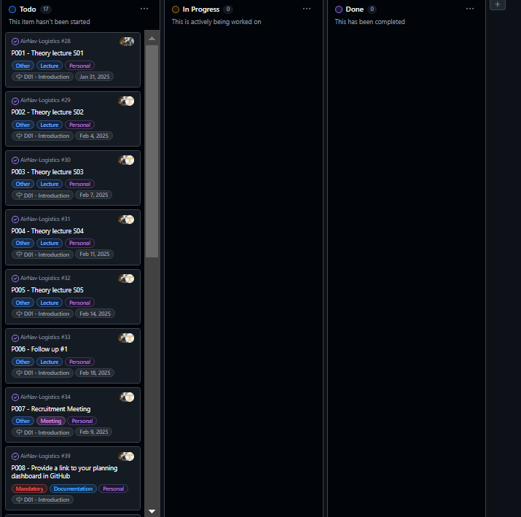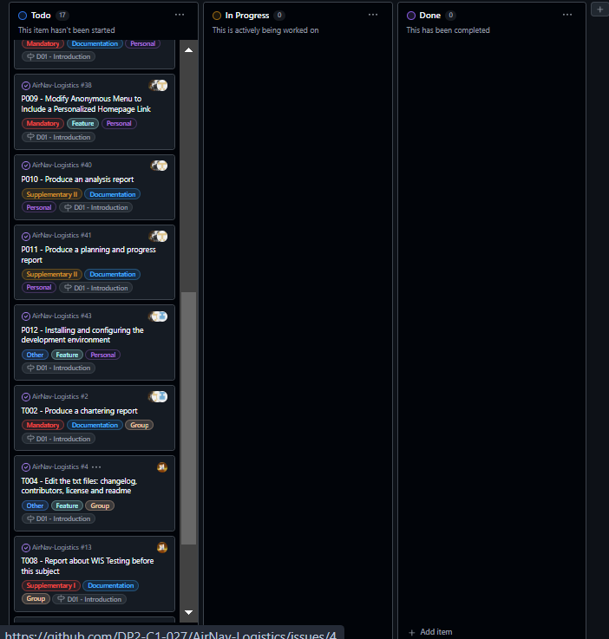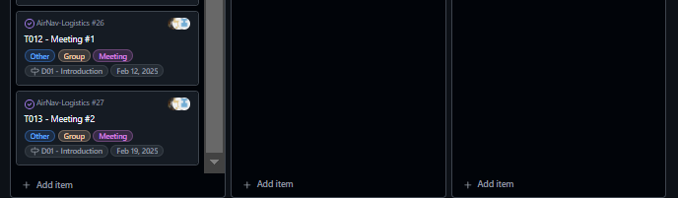

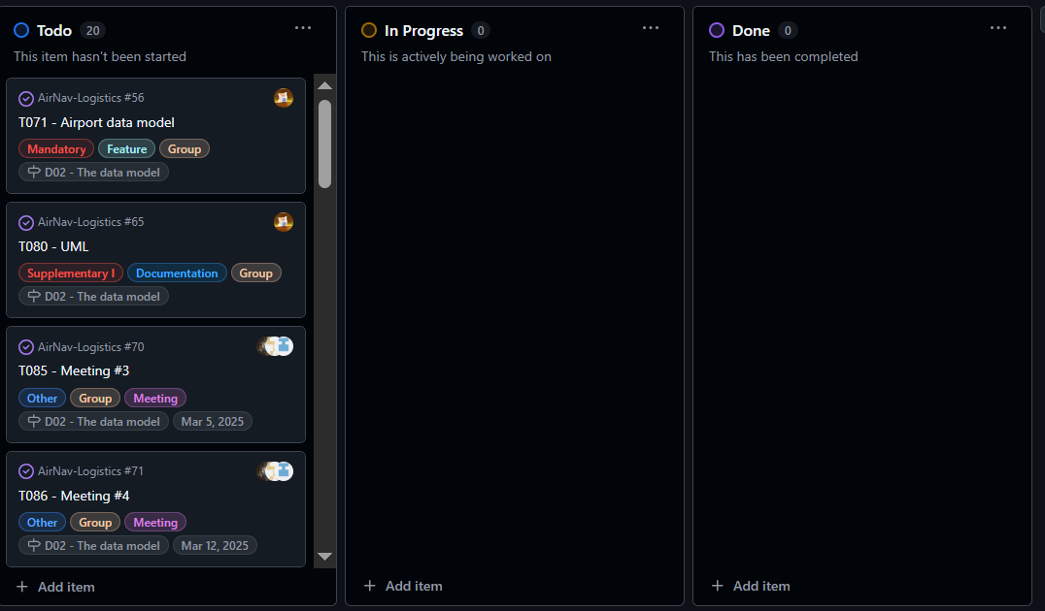 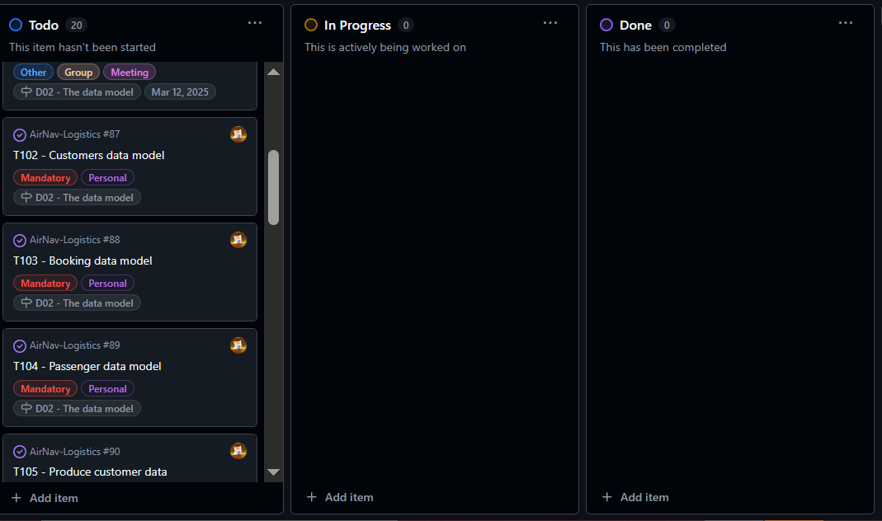 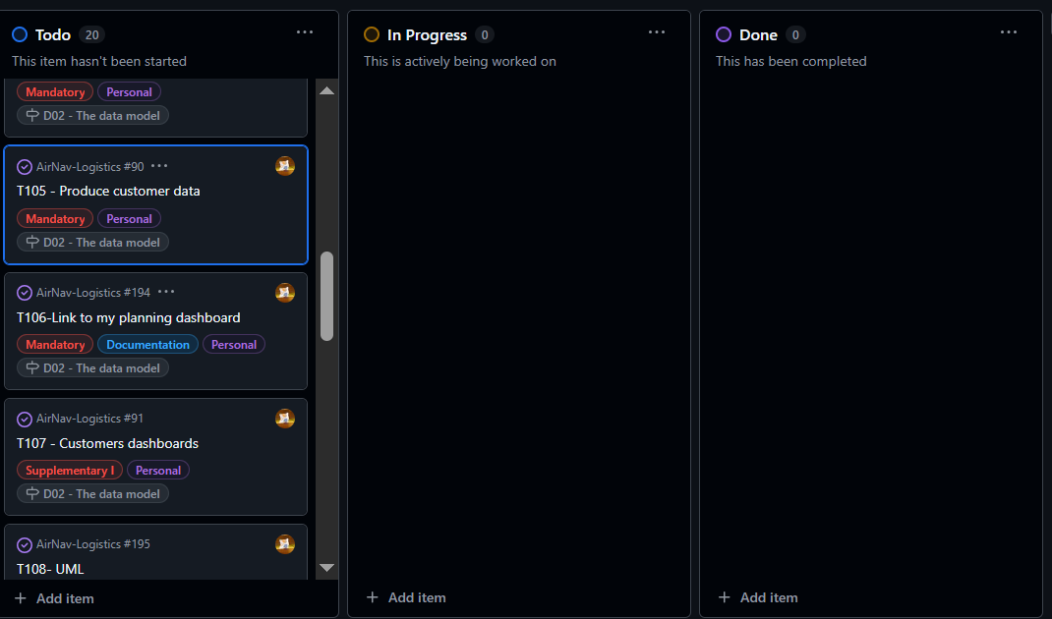 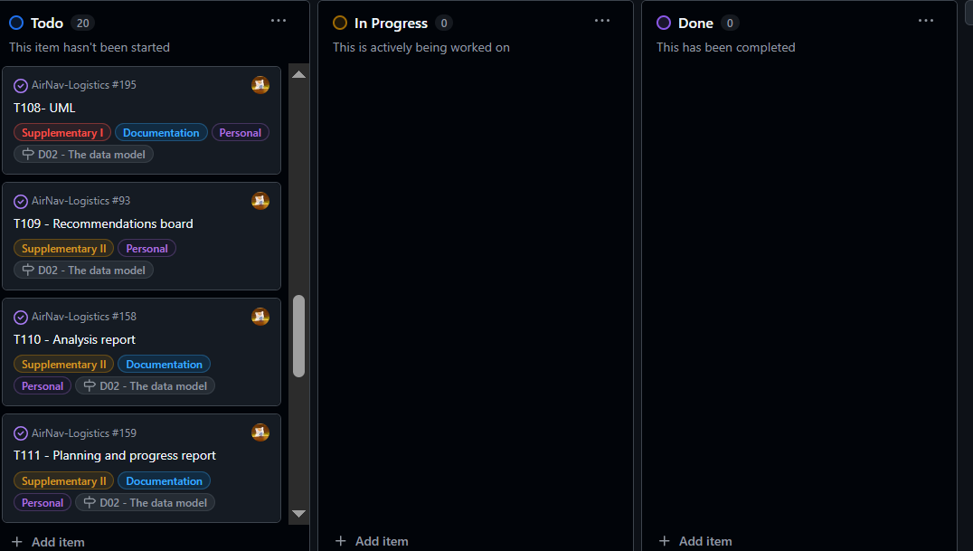 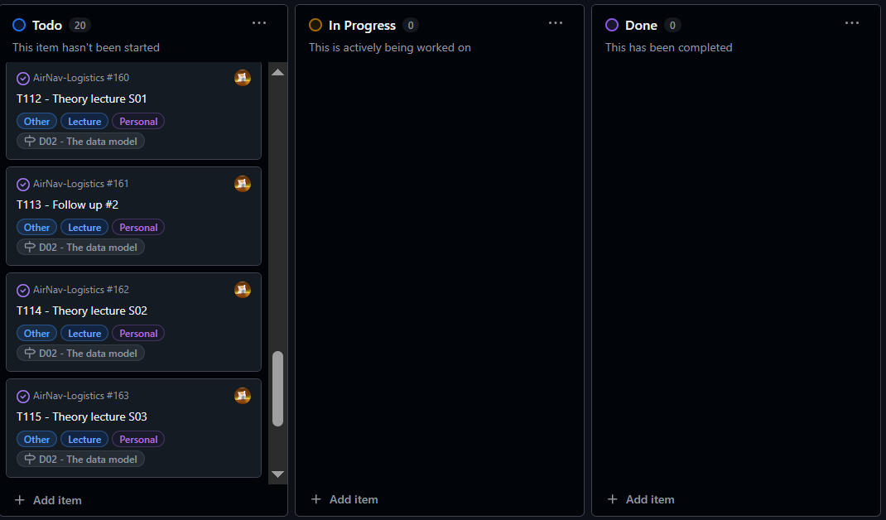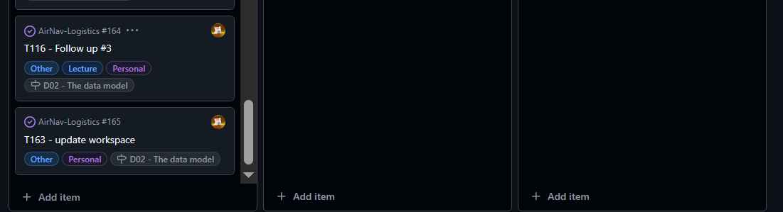

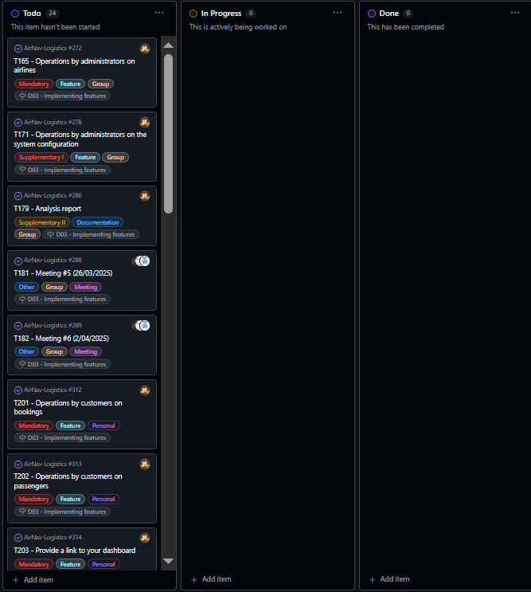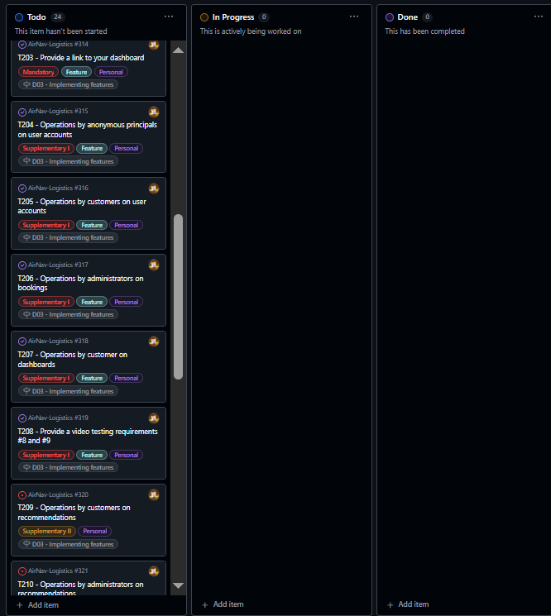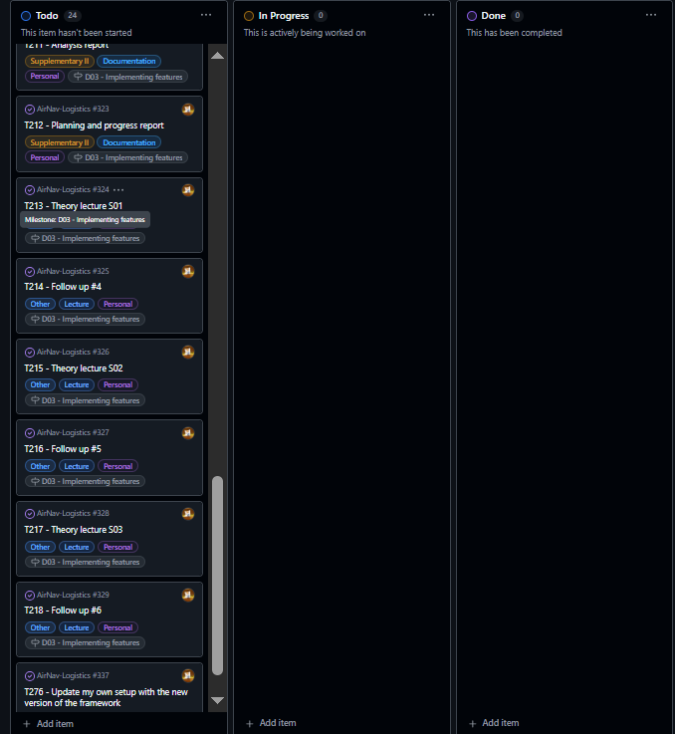

#### **2. Midway Through the Delivery: All Types of Tasks in Various Lanes**

Screenshot of the task board showing all kinds of tasks in various lanes, including regular tasks, quality-assurance tasks, and revisions as required.

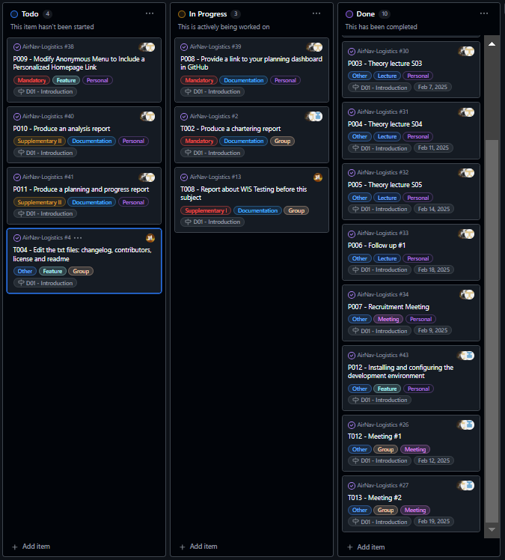

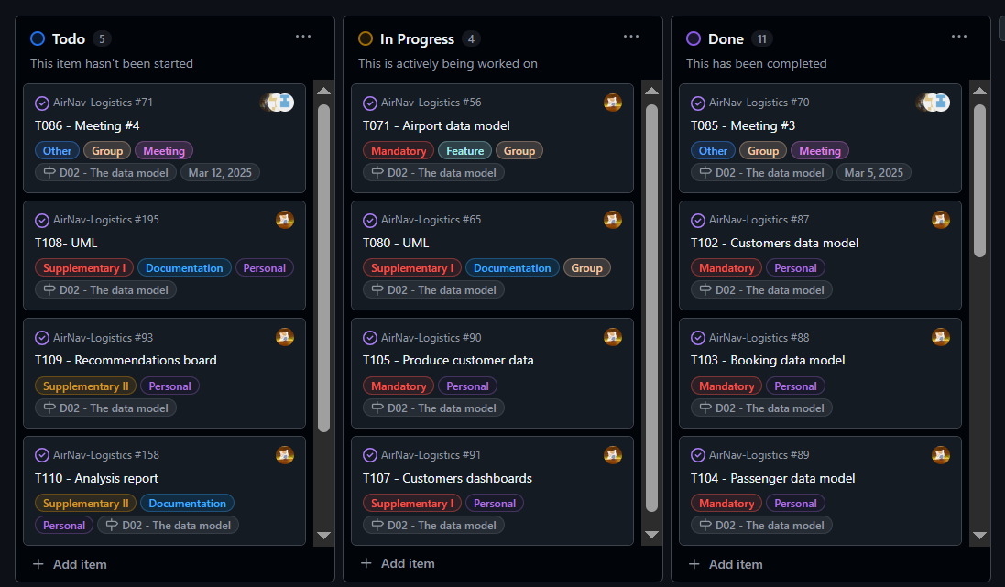 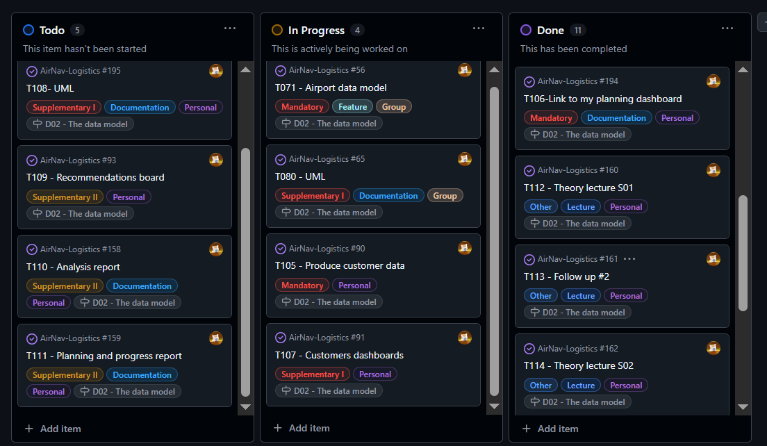 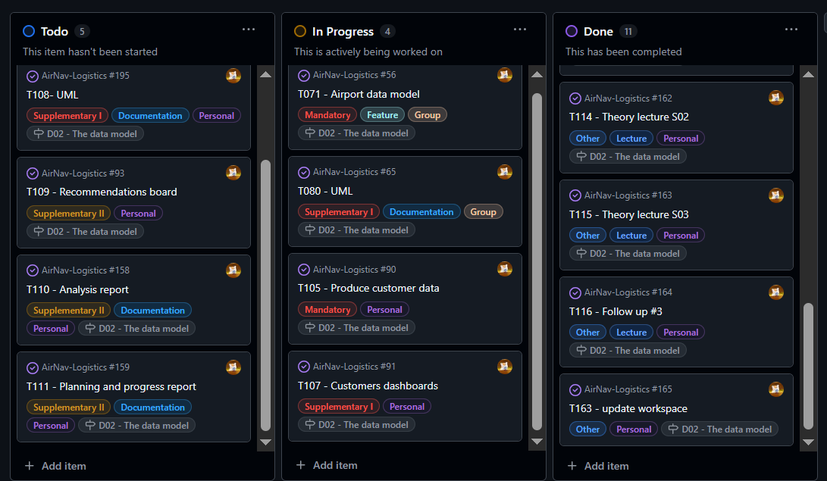

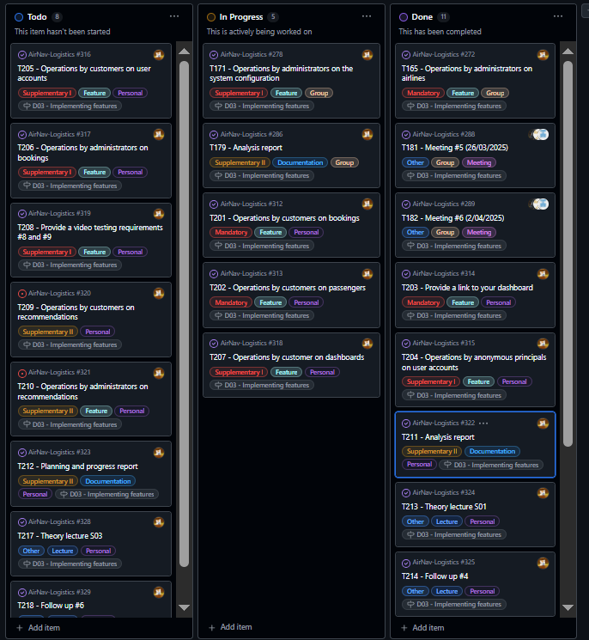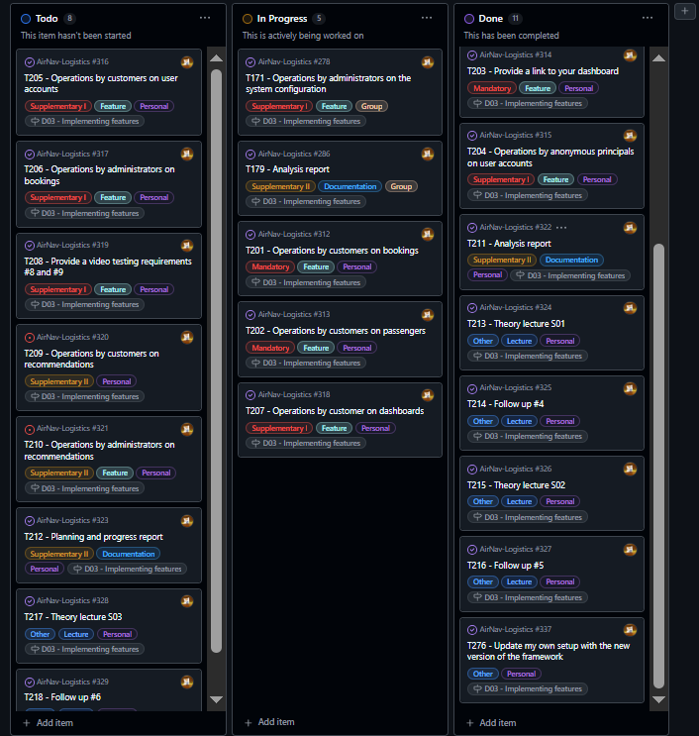

#### **3. Final Task Completion in the "Done" Lane**

Screenshot of all completed tasks in the "Done" lane, indicating the successful completion of all deliverables.

­

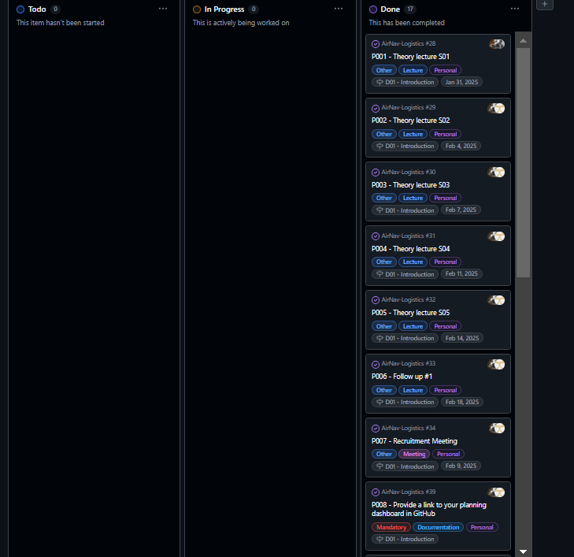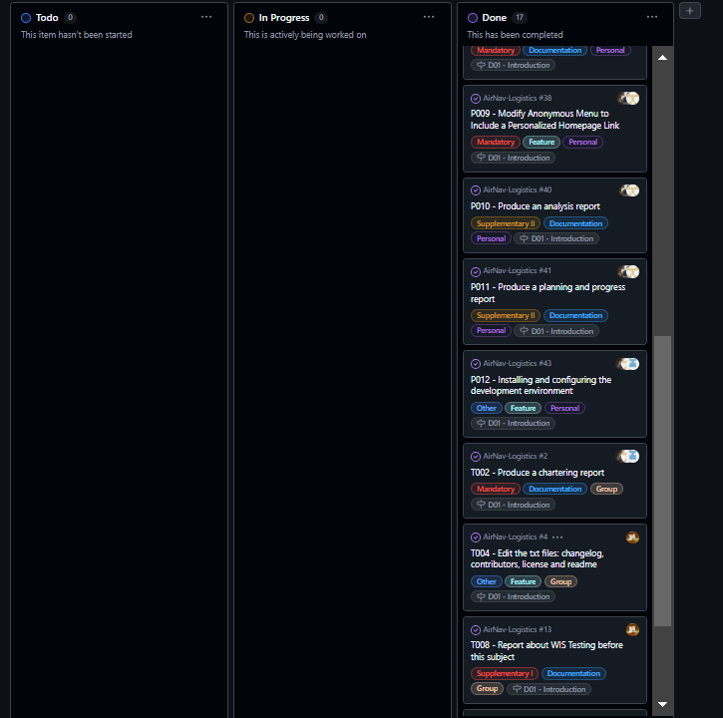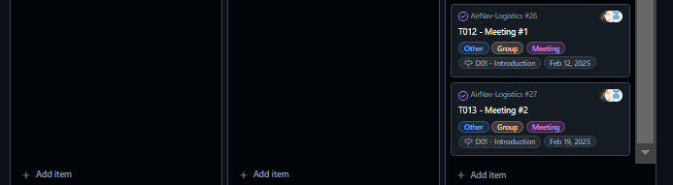

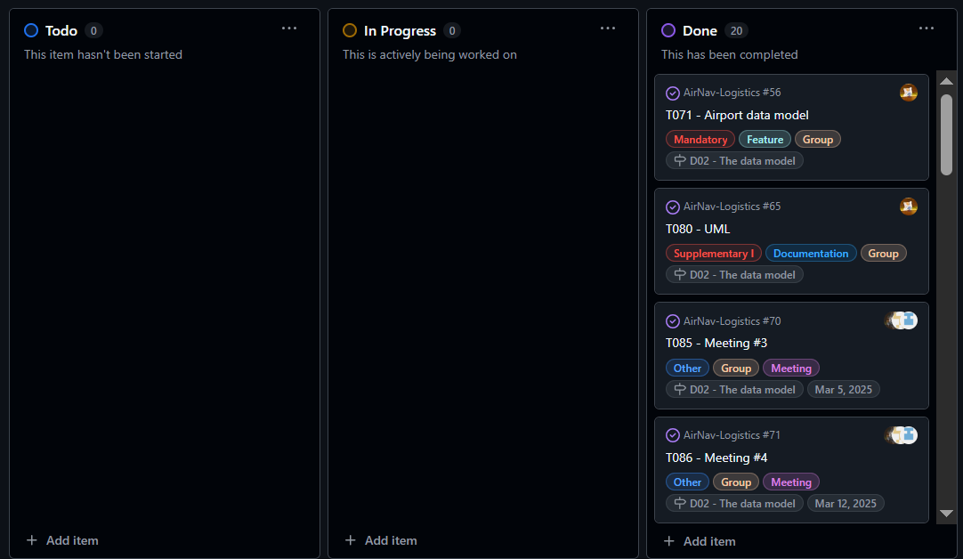 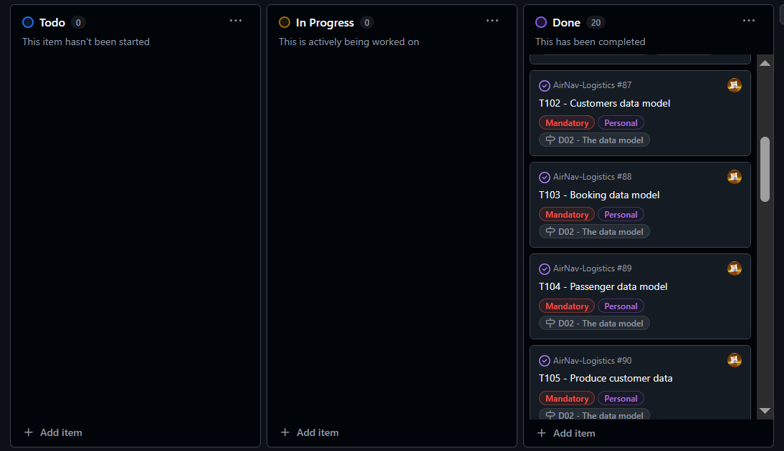

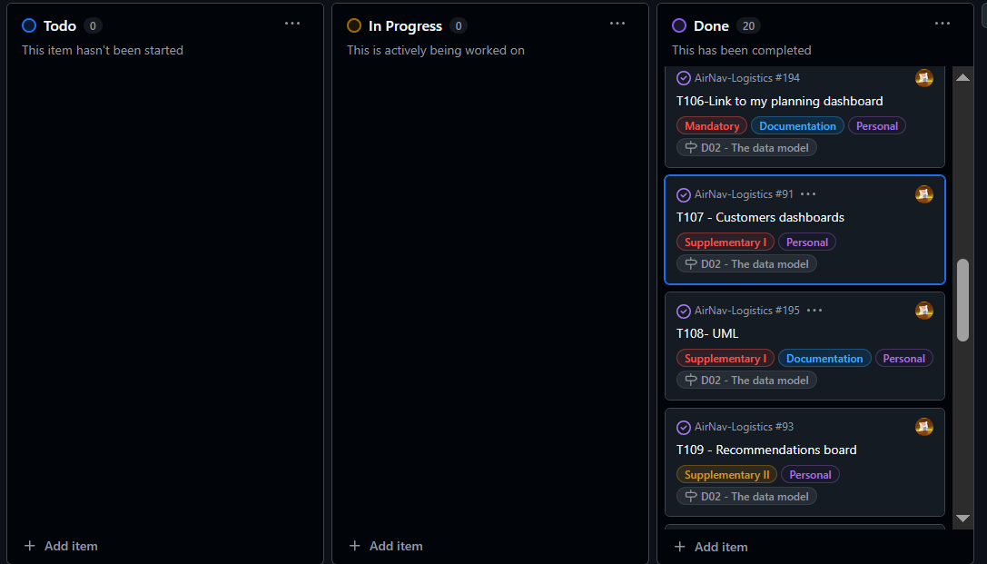 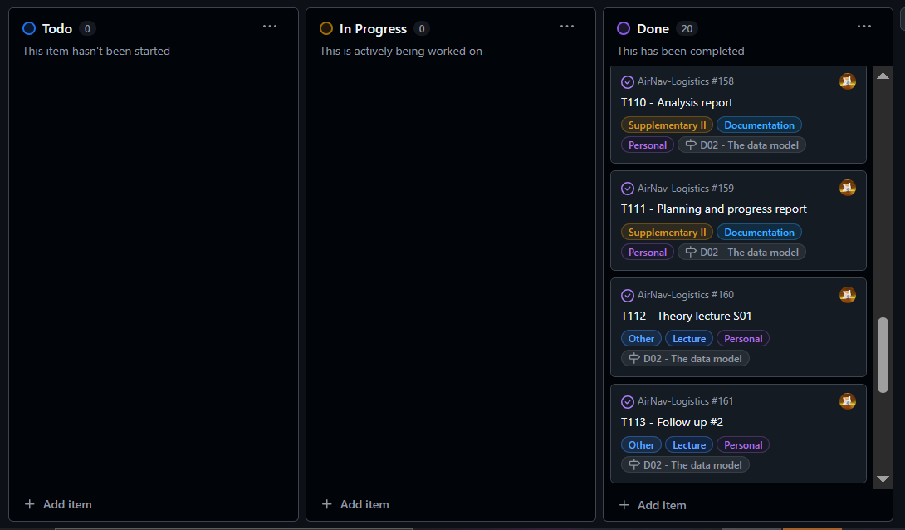 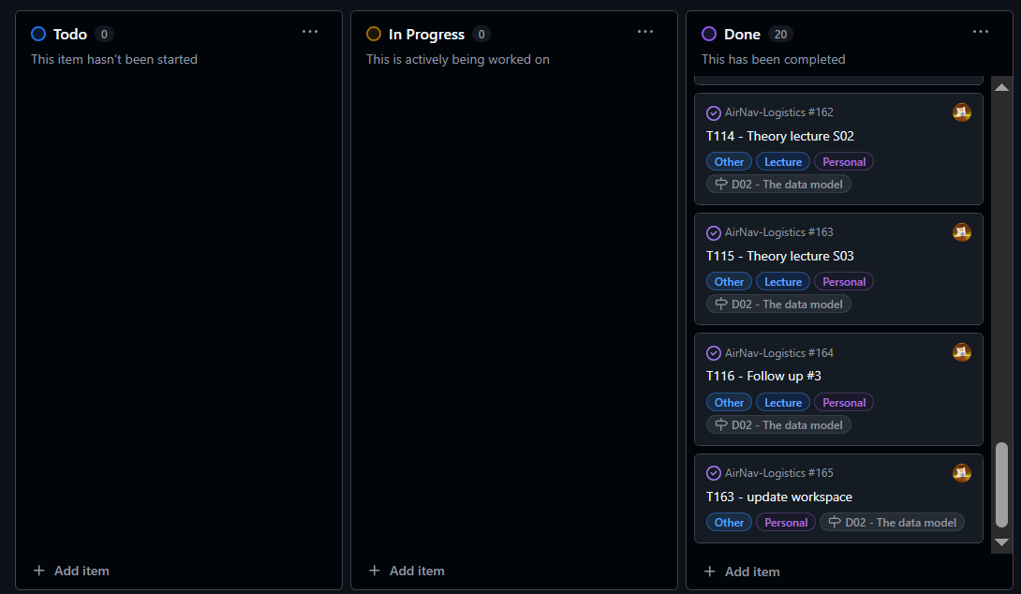

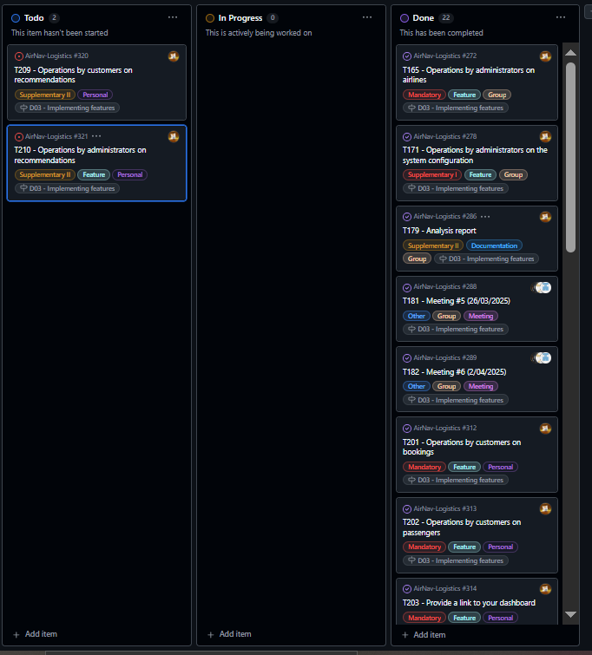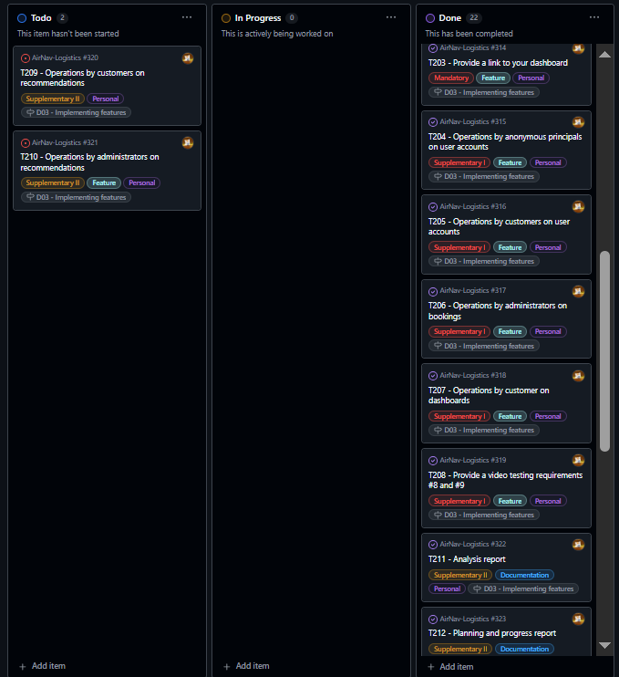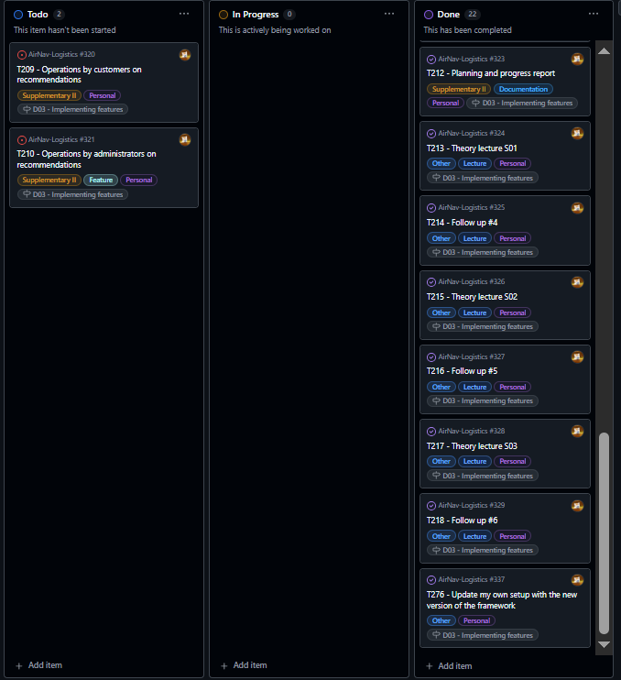

### **Estimated Budget**

**Estimated hours by role:**

**🡪D01:**

|  |  |  |
| --- | --- | --- |
| **Task** | **Role** | **Estimated Hours** |
| Modify the anonymou menu | Developer (Nora Peñaloza) | |  | | --- | |  |  |  | | --- | | 0.5 | |
| Provide a link to the GitHub planning dashboard | Developer (Nora Peñaloza) | |  | | --- | |  |  |  | | --- | | 0.5 | |
| Planning and Progress Report | Developer (Nora Peñaloza) | 3.0 |
| Analysis Report | Developer (Nora Peñaloza) | 3.0 |
| Edit text files (changelog, contributors, license, readme) | Developer (Nora Peñaloza) | 1.5 |
| WIS Testing Report | Developer (Nora Peñaloza) | 2.0 |
| Set up workspace | Developer (Nora Peñaloza) | 5.0 |
| Attend classes | Developer (Nora Peñaloza) | 9.0 |
| Recruitment Meeting | Developer (Nora Peñaloza) & Manager (Manuel Jesús Niza) | 0.5 |
| Meeting 1 | All team members | 1.0 |
| Meeting 2 | All team members | 1.0 |
| **Total Estimated Hours** |  | 27 hours |

**🡪D02:**

|  |  |  |
| --- | --- | --- |
| **Task** | **Role** | **Estimated Hours** |
| Customers data model | Developer (Nora Peñaloza) | |  | | --- | |  |  |  | | --- | | 1.0 | |
| Booking data model | Developer (Nora Peñaloza) | |  | | --- | |  |  |  | | --- | | 1.0 | |
| Passenger data model | Developer (Nora Peñaloza) | 1.0 |
| Produce customer data | Developer (Nora Peñaloza) | 1.0 |
| Provide a link to the GitHub planning dashboard | Developer (Nora Peñaloza) | 0.5 |
| Customers dashboard | Developer (Nora Peñaloza) | 2.0 |
| UML | Developer (Nora Peñaloza) | 0.5 |
| Recommendations board | Developer (Nora Peñaloza) | 2.0 |
| Attend classes | Developer (Nora Peñaloza) | 7.5 |
| Update the workspace | Developer (Nora Peñaloza) | 1.5 |
| Planning and Progress Report | Developer (Nora Peñaloza) | 3.0 |
| Analysis Report | Developer (Nora Peñaloza) | 3.0 |
| |  | | --- | |  |  |  | | --- | | Meeting 3 | | Everyone | 1.0 |
| Meeting 4 | Everyone | 1.0 |
| UML | Developer (Nora Peñaloza) | 0.5 |
| Airport data model | Developer (Nora Peñaloza) | 1.0 |
| **Total Estimated Hours** |  | 27.5 hours |

**🡪D03:**

|  |  |  |
| --- | --- | --- |
| **Task** | **Role** | **Estimated Hours** |
| Operations by customers on booking | Developer (Nora Peñaloza) | |  | | --- | |  |  |  | | --- | | 2.0 | |
| Operations by customers on passenger | Developer (Nora Peñaloza) | |  | | --- | |  |  |  | | --- | | 2.0 | |
| Provide a link to the GitHub planning dashboard | Developer (Nora Peñaloza) | 0.5 |
| Operations by anonymous principals on user accounts | Developer (Nora Peñaloza) | 2.0 |
| Operations by customer on user accounts | Developer (Nora Peñaloza) | 2.0 |
| Operations by administrators on booking | Developer (Nora Peñaloza) | 2.0 |
| Operations by customers on dashboars | Developer (Nora Peñaloza) | 1.0 |
| Provide a link to a video testing requirements #8 and #9 | Developer (Nora Peñaloza) | 1.0 |
| Attend classes | Developer (Nora Peñaloza) | 9.0 |
| Update the workspace | Developer (Nora Peñaloza) | 1.5 |
| Planning and Progress Report | Developer (Nora Peñaloza) | 3.0 |
| Analysis Report | Developer (Nora Peñaloza) | 3.0 |
| |  | | --- | |  |  |  | | --- | | Meeting 5 | | Everyone | 1.0 |
| Meeting 6 | Everyone | 1.0 |
| Analysis Report | Developer (Nora Peñaloza) | 2.0 |
| Operations by administrators on the system configuration | Developer (Nora Peñaloza) | 2.0 |
| **Total Estimated Hours** |  | 35 hours |

# **Cost by Role and Task**

**🡪D01:**

|  |  |  |  |  |
| --- | --- | --- | --- | --- |
| Task | Role | Estimated Hours | Hourly Rate | Estimated Cost |
| Modify the anonymous menu | Developer (Nora Peñaloza) | 0.5 | €20 | €10.00 |
| Provide a link to the GitHub planning dashboard | Developer (Nora Peñaloza) | 0.5 | €20 | €10.00 |
| Planning and Progress Report | Developer (Nora Peñaloza) | 3.0 | €20 | €60.00 |
| Analysis Report | Developer (Nora Peñaloza) | 3.0 | €20 | €60.00 |
| Edit text files (changelog, contributors, license, readme) | Developer (Nora Peñaloza) | 1.5 | €20 | €30.00 |
| WIS Testing Report | Developer (Nora Peñaloza) | 2.0 | €20 | €40.00 |
| Set up workspace | Developer (Nora Peñaloza) | 5.0 | €20 | €100.00 |
| Attend classes | Developer (Nora Peñaloza) | 9.0 | €20 | €180.00 |
| Recruitment Meeting | Developer (Nora Peñaloza) & Manager (Manuel Jesús Niza) | 0.5 | €20 | €10.00 |
| Meeting 1 | All team members | 1.0 | €20 | €20.00 |
| Meeting 2 | All team members | 1.0 | €20 | €20.00 |
| **Total Estimated** |  |  |  | 540.00 |

**🡪D02:**

| **Task** | **Role** | **Estimated Hours** | **Hourly Rate (€)** | **Estimated Cost (€)** |
| --- | --- | --- | --- | --- |
| Customers data model | Developer (Nora Peñaloza) | 1.0 | 20 | 20.00 |
| Booking data model | Developer (Nora Peñaloza) | 1.0 | 20 | 20.00 |
| Passenger data model | Developer (Nora Peñaloza) | 1.0 | 20 | 20.00 |
| Produce customer data | Developer (Nora Peñaloza) | 1.0 | 20 | 20.00 |
| Provide a link to the GitHub planning dashboard | Developer (Nora Peñaloza) | 0.5 | 20 | 10.00 |
| Customers dashboard | Developer (Nora Peñaloza) | 2.0 | 20 | 40.00 |
| UML | Developer (Nora Peñaloza) | 0.5 | 20 | 10.00 |
| Recommendations board | Developer (Nora Peñaloza) | 2.0 | 20 | 40.00 |
| Attend classes | Developer (Nora Peñaloza) | 7.5 | 20 | 150.00 |
| Update the workspace | Developer (Nora Peñaloza) | 1.5 | 20 | 30.00 |
| Planning and Progress Report | Developer (Nora Peñaloza) | 3.0 | 20 | 60.00 |
| Analysis Report | Developer (Nora Peñaloza) | 3.0 | 20 | 60.00 |
| Meeting 3 | Everyone | 1.0 | 20 | 20.00 |
| Meeting 4 | Everyone | 1.0 | 20 | 20.00 |
| UML | Developer (Nora Peñaloza) | 0.5 | 20 | 10.00 |
| Airport data model | Developer (Nora Peñaloza) | 1.0 | 20 | 20.00 |

# **Total Estimated Cost 550.00**

**🡪D03:**

|  |  |  |  |  |
| --- | --- | --- | --- | --- |
| **Task** | **Role** | **Estimated Hours** | Hourly Rate | Estimated Cost |
| Operations by customers on booking | Developer (Nora Peñaloza) | |  | | --- | |  |  |  | | --- | | 2.0 | | €20 | €40 |
| Operations by customers on passenger | Developer (Nora Peñaloza) | |  | | --- | |  |  |  | | --- | | 2.0 | | €20 | €40 |
| Provide a link to the GitHub planning dashboard | Developer (Nora Peñaloza) | 0.5 | €20 | €10 |
| Operations by anonymous principals on user accounts | Developer (Nora Peñaloza) | 2.0 | €20 | €40 |
| Operations by customer on user accounts | Developer (Nora Peñaloza) | 2.0 | €20 | €40 |
| Operations by administrators on booking | Developer (Nora Peñaloza) | 2.0 | €20 | €40 |
| Operations by customers on dashboars | Developer (Nora Peñaloza) | 1.0 | €20 | €20 |
| Provide a link to a video testing requirements #8 and #9 | Developer (Nora Peñaloza) | 1.0 | €20 | €20 |
| Attend classes | Developer (Nora Peñaloza) | 9.0 | €20 | €180 |
| Update the workspace | Developer (Nora Peñaloza) | 1.5 | €20 | €30 |
| Planning and Progress Report | Developer (Nora Peñaloza) | 3.0 | €20 | €60 |
| Analysis Report | Developer (Nora Peñaloza) | 3.0 | €20 | €60 |
| |  | | --- | |  |  |  | | --- | | Meeting 5 | | Everyone | 1.0 | €20 | €20 |
| Meeting 6 | Everyone | 1.0 | €20 | €20 |
| Analysis Report | Developer (Nora Peñaloza) | 2.0 | €20 | €40 |
| Operations by administrators on the system configuration | Developer (Nora Peñaloza) | 2.0 | €20 | €40 |
| **Total Estimated** |  | €700 |  |  |

# **Amortization Cost**

The annual amortization cost for the infrastructure is **€20.00**, calculated using a linear method over three years.

# **Total Estimated Budget**

|  |  |
| --- | --- |
| Concept | Estimated Cost |
| Personnel Cost | €540.00 |
| Amortization | €20.00 |
| Total Estimated | €560.00 |

|  |  |
| --- | --- |
| Concept | Estimated Cost |
| Personnel Cost | €550.00 |
| Amortization | €20.00 |
| Total Estimated | €570.00 |
| Concept | Estimated Cost |
| Personnel Cost | €700.00 |
| Amortization | €20.00 |
| Total Estimated | €720.00 |

**Progress Chapter**

#### **Progress Records**

|  |  |  |  |
| --- | --- | --- | --- |
| **Team Member** | **Performance Indicators** | **Value** | **Description** |
| Nora Peñaloza | Task Completed | Good | All tasks completed on time and within the estimated time. |

### **Reward/Admonishment**

### No formal reward was applied, but Nora's efficient completion of tasks is noted as a positive contribution to the team’s success.

### **Conflicts and Resolution**

No major conflicts arose during development. The team members worked collaboratively to address any technical challenges independently.

#### **Cost Comparison**

|  |  |  |
| --- | --- | --- |
| **Cost Component** | **Estimated Cost** | **Real Cost** |
| **Developer (Nora Peñaloza)** | **€540** | **€500** |
| **Amortization** | **€20.00** | **€20.00** |
| **Total Cost** | **€560.00** | **€520.00** |

|  |  |  |
| --- | --- | --- |
| **Cost Component** | **Estimated Cost** | **Real Cost** |
| **Developer (Nora Peñaloza)** | **€550** | **€573.40** |
| **Amortization** | **€20.00** | **€20.00** |
| **Total Cost** | **€570.00** | **€593.40** |

|  |  |  |
| --- | --- | --- |
| **Cost Component** | **Estimated Cost** | **Real Cost** |
| **Developer (Nora Peñaloza)** | **€700** | **€750.20** |
| **Amortization** | **€20.00** | **€20.00** |
| **Total Cost** | **€720.00** | **€770.20** |

### The real cost aligns with the estimated cost, confirming that the project has remained on budget.

## **Conclusions**

The *AirNav-Logistics* project is progressing as planned. The assigned tasks have been completed within the established timelines and budget. There were no major deviations from the estimated costs, and Nora’s performance has been instrumental in ensuring the success of the project. The work has been carried out efficiently, and the resources used have been sufficient to meet the project’s requirements.

## **Bibliography**

Intentionally blank.